Section: Non Verbal Reasoning - Figures

Image : 1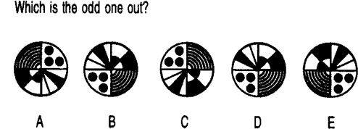Please refer Image 1 for the next question
Choose the correct option.

Q.1

A: A | B: B | C: C | D: D | E: E
Image : 2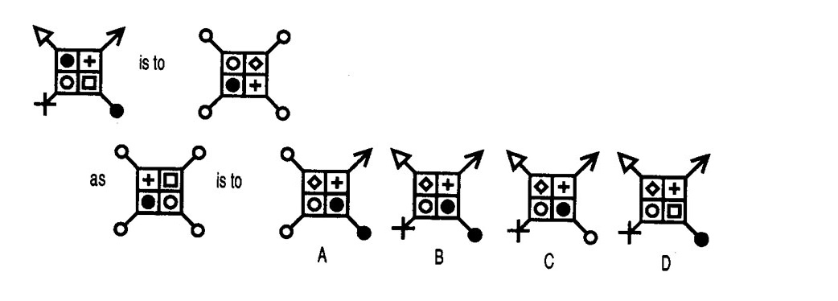Please refer Image 2 for the next question
Choose the correct option.

Q.2

A: A | B: B | C: C | D: D | E: E
Image : 3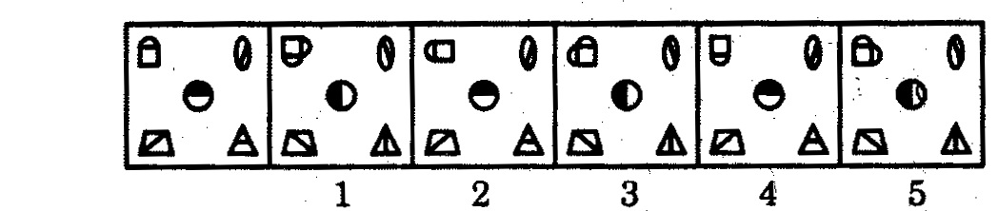Please refer Image 3 for the next question
Directions: Each of the following problem consists of a set of six figures, the first of which is unnumbered and marks the beginning of the series which is continued in the successive figures numbered from 1 to 5. However, the series will be established only if the positions of two of the numbered figures are interchanged. The number of the earlier of the two figures is the answer. If no two figure need to be interchanged, then the answer is 5. Choose the correct answer.

Q.3

A: A | B: B | C: C | D: D | E: E
Image : 4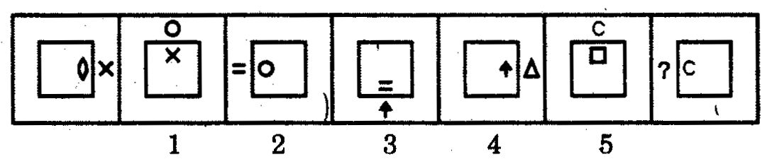Please refer Image 4 for the next question
Direction : In each of the following questions, there are seven figures, the first and last of which are unnumbered and the remaining are numbered as 1, 2, 3, 4 and 5. These seven figures form a series. However, one of the five numbered figures does not fit into the series. The number of that figure is the answer.

Q.4

A: 1 | B: 2 | C: 3 | D: 4 | E: 5
Image : 5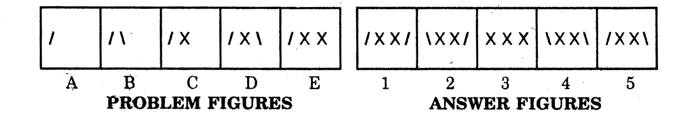Please refer Image 5 for the next question
Directions : Each of the following quetion consist of five figures marked A,B,C,D, and E called the Problem Fighures followed by five other figures marked 1,2,3,4 and 5 called the Answer Figures. Select a figure from amongst the Answer figures which will continue the same series as established by the five Problem Figures.

Q.5

A: 1 | B: 2 | C: 3 | D: 4 | E: 5

